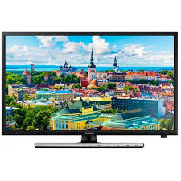

Samsung J4100

* Auto Channel Search
* Digital Clean View
* HD Features
* Screen Size 32 Inches
* **Rs, 32,499**